Shabbos Stories for
Parshas Vayera 5775
Volume 6, Issue 8 15 Mar Cheshvon 5775/ November 8, 2014
Printed L’illuy nishmas Nechama bas R’ Noach, a”h

For a free subscription, please forward your request to keren18@juno.com
Hard Times for the Upper West Side’s Venerable Judaica Store
West Side Judaica has been a fixture in Manhattan for 80 years.
Now, rising rent and online competition threaten its future.
By Zachary Schrieber

In the 1980s, the southeastern corner of Broadway and 88th Street on Manhattan’s Upper West Side hosted a camera store, a liquor store, a pharmacy, and West Side Judaica. Most of those businesses are long gone. Today a TD Bank encompasses what used to be four separate storefronts; a ladies’ hat store called La-Di-Da closed its doors just a few weeks ago.
But West Side Judaica remains, after eight decades in business, selling Jewish items ranging from yarmulkes to religious artwork, Shari Lewis DVDs to silver kiddush cups, educational children’s toys in Hebrew to the writings of the Slonimer Rebbe. It serves a wide range of New York’s Jewish community with a rare sense of openness; it’s the kind of place where you might find an Orthodox sales clerk showing a liberal Jewish woman how to wrap her first tallit. “The store is a fixture of the community,” said Rabbi Moshe Grussgott of Congregation Ramath Orah on the Upper West Side.
How much longer the store can go on, however, is another question. Rising rents and increased competition from online vendors means that business is less profitable than it once was. The High Holidays are always a good season; last week, for instance, while shofars still hung from the ceiling, the store was selling items for Sukkot: schach (bamboo branches) and other things to decorate a sukkah, as well as lulavim and etrogim.
Owner Yaakov Saltzer told me on a recent visit that sales have “picked up a little in the last couple months, not including the usual bump for the holidays.” But still, he says, West Side Judaica—one of just two Judaica stores left in Manhattan, and the only one on the heavily Jewish Upper West Side—is “just staying afloat.”

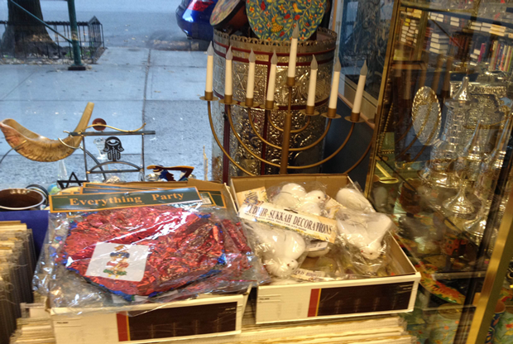
Sukkah decorations among other religious items for sale recently.(Zachary Schrieber)

***
West Side Judaica opened in 1934 and was later sold in the 1960s, before Saltzer purchased the store in 1980. When Saltzer took over, West Side Judaica was literally half the store it is today: Sales were good in the 1980s and he moved the store to a new location, double the size, in the middle of the block. At that time, “we were one of a dozen or so [Judaica] stores in Manhattan. Now it’s just us and J. Levine,” he said, referring to a bookstore and Judaica shop some 60 blocks away on West 30th Street.
In the 1980s, Saltzer says, he was paying around $1,500 per month in rent. Now, he says he pays more than 10 times that. But he does not blame anyone for the increases: “It’s nobody’s fault, it just is what it is. The same thing is happening all over the city.”
But the dramatic rent increases are not the only problem. Like many bricks-and-mortar stores, West Side Judaica has fallen victim to the robust growth in online shopping. When I asked Saltzer where people go to buy their books nowadays, he pointed to his computer: “The Internet.” (West Side Judaica does not maintain an online retail space.)
But the store has also suffered from increased competition from an unexpected place: When the Museum of Jewish Heritage opened in the late 1990s, its vast resources dramatically hurt book sales at West Side Judaica. “I was the only one with the scholarly books [on the Holocaust],” said Saltzer. “Professors knew to come here. Now they go there, or they get them online.”

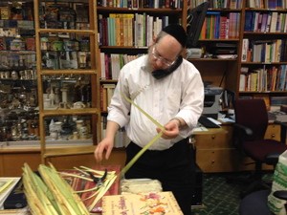
Shlomo Saltzer, Yaakov’s brother, talks to a client
while tying together lulavim in preparation for Sukkot.

In 2012, the Abraham Joshua Heschel School moved its early-childhood and middle schools from around the corner to its new campus on 61st Street. The school still supports the store and encourages its students and their families to shop at West Side Judaica. But the move cost the store quite significantly. “Parents would stop in and buy something when they came to pick up their children,” said Erica Saltzer, Yaakov’s mother. “Now many have little reason to be in the area and no longer come in.”

The store is clean and tidy, but there are indications that this congruence of negative factors has hit the store pretty hard. A giant “50% off sale” sign for books is taped to the front window, in an attempt to compete with the steep discounts of online retailers. Another sign asks people to “please shop local.” The heavy foot traffic on Broadway after work has dropped in recent years and now yields just a few walk-ins, which Saltzer claims are not enough to “sustain” the store. The trend lines are clear to see.
For the time being, West Side Judaica still has a dedicated clientele of local synagogues and Jewish organizations. Grussgott, for instance, was purchasing yahrzeit candles and white yarmulkes for some members of his synagogue when I visited. “We generally get all our Judaica needs from them,” he told me. “It’s nice because it’s a neighborhood store.”
“There are still some regulars,” said Saltzer, who have kept the West Side Judaica alive during these tough times. A family called the Kukoffs, who after decades on the Upper West Side now live in the Upper Hudson Valley area, still drive two-and-a-half hours to come to the city every few weeks. “Every time we visit the city we always make sure to stop by West Side Judaica to visit and buy something,” Mr. Kukoff told me. On this trip, they purchased a Conservative luach (a calendar with the times and dates of Jewish holidays) and a Jewish Museum calendar.
Saltzer and the rest of the staff are Orthodox, but he does his best to ensure that the diverse community of Jews on the Upper West Side is properly catered to. A study from 2011 showed that 13 percent of Jews in the area identify as Orthodox, but 21 percent identify as Reform and 20 percent as Conservative. Robert Owen, an accountant, and Daniella Kolodny, a Conservative rabbi, were visiting from London for a few days for a bar mitzvah and stopped in.
She had frequented the store when she lived on the Upper West Side and noted how this store differs from the Judaica houses in London. “West Side is a great bookstore,” Kolodny said. “In London it’s only Orthodox items, but here they have a real diversity of books.” Although many shelves of West Side Judaica are filled with Talmudic texts, the store also sells English texts on Jewish philosophy and feminism.
In one corner is a rack of tallitot, which includes a pink tallit. “Many women throughout history have worn the tallit,” Saltzer told me proudly. “Anyone who wants to practice Judaism, we got it.” Drawers are filled with yarmulkes and other small religious articles. Shofars hang from the ceiling. Silver Kiddush cups and menorahs line one wall while the other contains nearly every Jewish book imaginable. On the counter there is some artisanal honey from Israel. The price reads: “$8.99. For you, special price: $7.00.”
Gloria Kauffman, a well-dressed woman in her 70s, is a regular; she came in as she does every holiday season to purchase cards and gifts for her many grandchildren. Tommy Vance, an unaffiliated Jew in his late 20s, went in looking to purchase a mezuzah for a wedding gift but left with a menorah instead. “The staff could not have been more helpful,” he told me. “I left learning more about Judaism than I have in a long time.”
A handsome man named Aron, wearing a stylish gray suit and slicked-back hair but calling himself a Hasid, entered the store “just to say hello.” He told me that he usually comes in every day for mincha and considers the store a “great resource,” as West Side Judaica is the “only religious book store” in the area. “I buy all my Jewish books here, never online.” In addition, Aron said that, after years of living in New York with no connection to Judaism, “the brothers in the store have helped me come back to Judaism.”
Nearly all the staff is part of one large extended family. Yaakov’s brother and brother-in-law work there, and his wife is the bookkeeper. His mother works the register. He has five children and quite a few grandchildren. When I asked how many of them work in the store, Saltzer responded, “none,” before he smiled and added optimistically: “Maybe when things pick up a little.”

Reprinted from the October 7, 2014 edition of Tablet Magazine.

Rav Avigdor Miller’s Advice On Where to Daven When
One Needs a Major Refuah

Rav Avigdor Miller, zt”l, had a very close talmid, Rav Avraham Shlomo Yavo, who is the Rav of Nitei Avigdor in Williamsburg. When Rav Avigdor’s wife passed away, Rav Yavo delivered a eulogy at the levayah. Afterwards, a man came over to him and said, “I have a story to tell you, and I’d like for you to please tell it to your congregation.
“Several years ago,” he began, “I was diagnosed with a serious illness, and the doctors had given up all hope for me. They told me that ‘it was just a matter of time’ and there was nothing more they could do for me. Shattered, I went to Rav Avigdor Miller to ask him for a brachah.
“He asked me, ‘Where do you daven?’ When I told him where I davened, he asked, ‘Do they talk during davening there?’ I admitted that they did. Rav Avigdor said to me, ‘Don’t step into that Shul ever again!’
Rav Avigdor instructed, ‘Even if you daven perfectly, your tefilos are trapped by those people who talk during davening, and they cannot ascend to Heaven. Look for another Shul where they don’t talk!’
“I followed his advice, and several weeks later I went back to the doctor for a follow up visit. After a few repeat scans, the doctors thought I was a different person! Miraculously, the illness was disappearing!”
Rav Yavo thanked the man for sharing his story with him, and assured him he would give over that lesson from Rav Avigdor Miller. That Simchas Torah in Rav Yavo’s Shul, they were just about to begin Kol HaNe’orim, the Aliyah with all the children gathered around the Bimah.
Just then, with all the children already standing under the Tallis that was being held over their heads, a member of the Shul approached Rav Yavo with his son and begged him for a brachah.
He said, “Rebbe, my son was recently diagnosed with a terrible illness, and the doctors say that the prognosis is not good.” With tears in his eyes, Rav Yavo gave the child a brachah, and he wondered what more he could do for him.
Suddenly, Rav Yavo remembered the story he had heard about Rav Avigdor Miller, and as soon as the Aliyah of Kol HaNe’orim was over, with all the children still standing there, he gave a clop on the bimah and told everyone that there was a child in the crowd that has a terrible illness. He told them the story about how Rav Avigdor Miller advised the sick man to find a different Shul to daven in because the talking in that Shul was not allowing his tefilos to ascend up to Hashem.
Rav Yavo said, “We are about to start the Torah from the beginning, and read Parashas Bereishis. Let’s accept upon ourselves to make an extra effort not to talk during davening and leining for the next year, as a special zechus for this sick child!” Everyone agreed. Three months later, the father of this boy came running over to Rav Yavo and said “The doctor just informed me that the disease is completely gone! It’s a miracle! Baruch Hashem my son is entirely cured!!!”

Reprinted from last week’s email of “Torah U’Tefilah: A Collection of Inspiring Insights” as compiled by Rabbi Yehuda Winzelberg.

The Special Prayer
Of the Rav of Piltz
Late every Thursday night, the Rav of Piltz would daven a special tefilah: “Master of the Universe! Please let all the food that the Rebbetzin is cooking for Shabbos come out tasting delicious for Shabbos! Please let Shabbos come and fill me, my family, and my entire house with Shabbos Kedushah. Please, Hashem, let the food for all three Shabbos meals be filled with holiness as well! Please give the food the special flavor of Shabbos!”
Every week the Rav of Piltz would daven this special tefilah, and every week the Shabbos food would always come out delicious! (Sipurei Chassidim, p. 193)

Reprinted from last week’s email of “Torah U’Tefilah: A Collection of Inspiring Insights” compiled by Rabbi Yehuda Winzelberg

In The Rural West, 'Roving Rabbis' Reach Isolated Jews
By Stina Sieg

Mountains and forests surround the little town of Show Low, Ariz. It's home to only 10,000 people, but the heavily Mormon community is still the biggest place for more than hour in every direction.
It's not the kind of setting that typically fosters a thriving Jewish community — which is exactly why Hasidic rabbinical students Zalman Refson and Yaakov Kaplan are here.

Hitting The Road To Reach Rural Jews
Residents of the rural West have historically relied on the talents of people passing through — traveling doctors, traveling circus performers and traveling preachers. So-called roving rabbis like Refson and Kaplan are carrying on that tradition, meeting rural Jews who otherwise might rarely interact with others of their faith.
They're two of the hundreds of rabbinical students who travel to rural places all across the globe each year. These roving rabbis make these journeys in the name of Chabad, a movement within Orthodox Judaism.

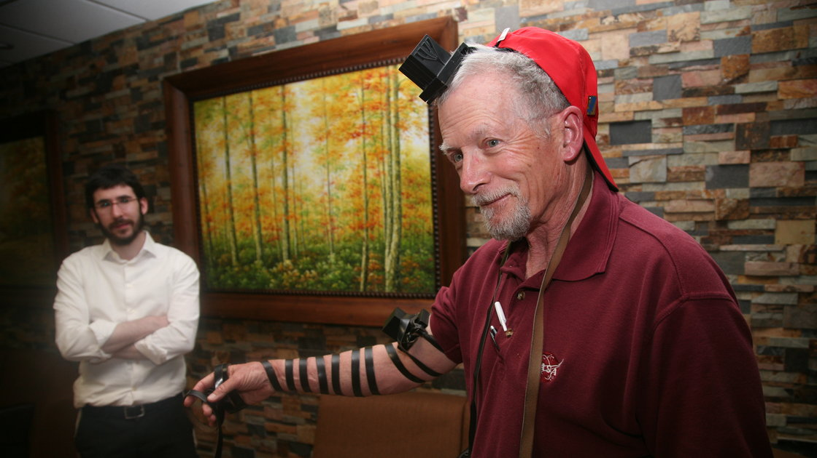
Rabbinical student Zalman Refson (left) recently traveled across Arizona as part of a duo of "roving rabbis," working to help rural Jews reconnect with their faith. Here, he helps Aaron Bornstein prepare for traditional prayer by laying tefillin, small leather boxes containing parchment inscribed with verses from the Torah that are fastened to the arm and forehead with leather strips.

Young, bearded and dressed in black pants and long-sleeved white shirts, even in the Arizona heat, the two men stick out in Show Low. Kaplan says being a roving rabbi is all about helping Jews reconnect to their faith.
"By going out to other people and just trying to have a Jewish conversation, it makes my conviction stronger," Kaplan says.
This program has been around more than 70 years. Both Kaplan and Refson have done it more than once, but never in Arizona, in an area known for sending out its Mormon sons and daughters to proselytize.
The rabbis don't use that term to describe their own work. On one level, Refson sees what he's doing as practice for having his own congregation someday.
"Meeting people and interacting with them on a very simple level, regardless of Jewish topics, is a very positive thing," he says. "And it's a very positive experience for a person who's going to enter the people business."

'If You're Jewish, You're Jewish'
The rabbis keep a list of Jews they know about in these small towns. Often, people request a visit — or their family elsewhere requests one for them. Some days, the rabbis just pick up a phone book and start looking for Jewish
Many of the Jews the rabbis meet are like Hilda Lochansky-Smith and have never been all that observant. As she invites the rabbis into her place and they get to chatting, Kaplan asks if she likes to cook Jewish food. Lochansky-Smith shakes her head. "I mean, I can make matzo ball soup and chicken soup, but I don't do it too much," she says.
Lochansky-Smith's favorite kosher dish was her grandmother's gefilte fish, but she also likes to joke about her late mother loving ham. She has hardly any Jewish friends and has even been attending a local Bible church in recent years. But in her heart, Lochansky-Smith says, she knows who she is.

"When push comes to shove, you're Jewish — and there's only one Jewish tribe," she says. "Am I right?"
Kaplan agrees: "If you're Jewish, you're Jewish," he says. "Hundred percent."
Many of the rabbis' interactions are like this: friendly, kind of light, more of a check-in than anything else. But it's not always this easygoing. Beth Hakenewerth, who lives in nearby Taylor, Ariz., cried on the phone with the rabbis the night before.

Discovering She Had Never Been Fully Converted
She's dealing with her father's death, and finding out her parents had never fully converted her to Judaism after she was adopted as a baby.
"I don't feel normal," she says. "I don't feel like myself anymore."
She says living far away from her family in California, and hundreds of miles from an established Jewish community, makes it harder. Hakenewerth has only ever met a handful of other Jews in this little town.
"But I just wish, I hope and pray that one of these days, that there'll be a shul up here, or Chabad learning center, or something like that," Hakenewerth says.
The roving rabbis are often seen as a threat to more liberal Jewish congregations for promoting a traditional version of the faith. But Kaplan says they're only trying to inspire Jews to be a little more observant.
His favorite part of this ground game, he says, "is when I see people which are happy that we came, and we were able to help them in any way, shape or form."
That feels the same, he says, regardless of which small town in Arizona he's visiting.

Reprinted from a transcription of a National Public Radio clip broadcast on September 28, 2014.
Killing a Dreamer:
An Arab Terrorist Killed Karen Yemima Mosquera, a Convert from Ecuador, but He Could Not Kill all Her Dreams.
By Sara Yoheved Rigler

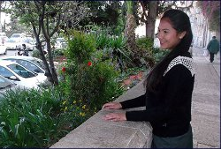

Born to a Christian family in Ecuador, Karen Mosquera was 17 years old when her genealogical research revealed that on her mother’s side she was descended from conversos [Spanish Jews who converted to Christianity in the 15th century during the Inquisition].
“She never accepted the teachings of the Church,” Yael Barros from Brazil, Karen’s best friend in the Jewish studies program in Jerusalem’s Old City, declares. She is sitting on her dorm bed, next to the bed that was Karen’s before she was murdered in a terrorist attack at a Jerusalem light rail station. An Arab terrorist rammed his car into a crowd of pedestrians, killing a three-month-old baby and critically wounding 22-year-old Karen.
“Anyone else would have died on impact,” testifies Karen’s cousin Sabrina, who saw her horrific injuries in the hospital ICU. “But Karen Yemima was so determined. She fought the angel of death for four days.” On Sunday, October 26, Karen succumbed to her wounds. She was buried on the Mount of Olives that night.

“Karen Yemima didn’t feel in her heart that the teachings of the Church were the real truth,” her friend Yael explains. “She told me that when she started studying Torah and mitzvot, everything made sense to her. And she was very, very happy studying Torah, like she had never been in her life.”
Becoming Jewish in Ecuador is an arduous process. There are no conversion courts and Jewish studies in her native city of Goayaquil were limited. But Karen always dreamed of going to Israel.
Very intelligent, at the age of 18, she was awarded a full scholarship to Goayaquil University. While she studied psychology during the day, she stayed up most of the night studying Judaism on the Internet. Through a Jewish friend, she met Israeli Spanish-speaking Rabbi Gavriel Geiber online. Impressed by Karen’s ardent interest in Judaism, Rabbi Geiber taught her through the computer. Karen started keeping mitzvot, praying the Jewish prayer services, making blessings on food, and dressing modestly.

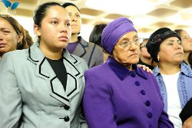
Karen’s mother at the funeral.

Her mother and younger sister followed suit. Like many descendants of conversos, Karen’s mother Rosa Cecilia observed customs that only later she discovered were Jewish. For example, when someone in the family died, Rosa Cecilia covered the mirrors. And following an arcane Sephardic custom, whenever she cut nails or hair, she burned the cut-off nails and hair rather than throw them away.
Sometimes Rosa Cecilia would wake up in the middle of the night and find Karen studying Torah. Once, she heard her begging God: “Take me to Israel! That’s my country! That’s where I’m going to marry and have children, and that’s where I’m going to die and be buried.”
A year and a half ago, Rosa Cecilia twice dreamed that her daughter Karen was travelling to Israel. She saw an airplane with the word “Israel” emblazoned on its side, and Karen was pulling a wheeled suitcase onto the plane. With great excitement, she told Karen about the dream, and added, “I want to buy you clothes that are appropriately modest for wearing in Israel.”
That was the impetus Karen was waiting for. Then in her third year of university, she responded, “Mom, I’m going to the university right now to cancel my enrollment and go to Israel.” Soon after, she arrived in Jerusalem, where Rabbi Geiber had arranged for her to live and study at Machon Roni in the Old City. As her best friend Yael remembers with admiration, “She was so brave. She left everything – her family, her studies – and came here alone.”

The Heavens Are Open
For a year, Karen studied Judaism. She also worked cleaning houses, saving up money to bring her family to Israel, which was another of her dreams. Indeed, her family would come to Israel, a trip paid for not by Karen’s meager savings, but by the Israeli Ministry of Foreign Affairs, which brings the family of foreign terror victims to attend their funerals.
Five months ago, Karen underwent conversion, taking the Hebrew name Yemima. As Yael explains, “When a person converts in the mikveh, the heavens are open. Karen Yemima came back to the dorm that day exalting, ‘Now you can ask me for anything! The heavens are open.’ She was so ecstatically happy.”
On her Facebook page that proud day she posted: “Thank You, Hashem, for the day I came to Israel! I got to see one of my dreams come true. And I hope to stay here for a long time. I hope to get to see my family share together with me this new life. Thank You, Hashem, that you never left me alone, and You keep giving me strength every day.”
“Karen Yemima was an example to all the other girls,” testifies Yael. She recalls one day when a group of the students was walking together in downtown Jerusalem. They had all bought juices, and as they were running to the bus, the other girls muttered their blessing over the juice before they drank. Only Karen Yamima stopped in the middle of the sidewalk, closed her eyes, and uttered the blessing with appropriate devotion.
When Karen Yemima and Yael had a free afternoon, they often would take a walk outside the Old City walls to Mount Zion. Sitting there, they would gaze at the view – the ancient Jewish cemetery on the Mount of Olives, where so many righteous Jews are buried. One day, Karen Yemima exclaimed, “Yael, I want to live here, to marry here, to have my children here. And I want to die here. And I know it’s impossible, but we can dream, can’t we? My dream is to be buried on the Mount of Olives, because when Moshiach [the Messiah] comes, I will be the first to rise up and be in the Holy Temple. Can you imagine that?”
On Wednesday, October 22, Karen Yemima finished work at the house that she cleans and was on the way to a Torah class. She alighted from the train at the Ammunition Hill station. Suddenly Abdel-Rahman Shaloudi, 21, who had been released from an Israeli prison where he had served time on terrorist charges, plowed his car into the crowd of disembarked passengers. He ran over Karen Yemima, inflicting mortal injuries, killed a 3-month-old baby, and injured several others.
The terrorist destroyed Karen Yemima’s dream to marry and have children, but sadly her dream to die in Israel and be buried on the Mount of Olives came true this week.

Reprinted from last week’s email of the Aish.com website.
Tales of the Gaonim

The Unmerciful Doctor
By Rabbi Sholom Klass

The Vilna Gaon was once called upon to litigate between a doctor and patient.
This doctor was a specialist who viewed pain and suffering as a blessing to the medical profession. He charged exorbitant sums for his services and never treated a needy person for free.
One day, a poor woman became critically ill and the distraught husband ran to the specialist and begged him to save her life.
“My dear man,” said the doctor coldly, “I may treat your wife for weeks and you don’t have sufficient funds to compensate me.”
“Doctor,” cried the desperate man, “you save her life and I’ll pay you every kopek even if I have to sell my house.”
“And suppose I can’t save her,” queried the physician, “won’t you pay me then?”
Promises to Pay the Doctor Whether
He Cures or Kills His Wife
“I’ll pay you whether you cure her or kill her,” shouted the loyal husband.
After treating the woman for a few weeks, she passed away.
With unseeming haste, the doctor sent the bereft man a bill for 1,000 rubles, but it received no attention. Subsequent letters were equally ignored. Eventually the doctor sued the delinquent debtor and the judge, seeing the poverty-stricken defendant, referred the case to the Vilna Gaon.
The Gaon heard the arguments and regarded the two litigants thoughtfully. It was unjust, thought the Gaon, to make the poor man sell his house and give the money to the avaricious practitioner and he determined to protect him.
After a few moments, the Gaon called the doctor to him.
“What was your agreement with the defendant?” inquired the Gaon, again.
“Our agreement was that I was to get paid whether I cured or killed her.”
“Did you cure her?” asked the Gaon.
“No,” replied the doctor, reluctantly. “It was impossible.”
“Did you kill her?” was the next question.
“Oh no, I should say not,” answered the doctor.
“Then,” declared the Gaon, “you have no claim, for you neither cured her nor killed her.”

The Power Of Repentance
A wonderful story is recorded about the Maharil, Rav Yaakov ben Moshe Mollin, who proved the power of repentance
The Maharil was the first rav to bear the title Morenu. He was considered the greatest authority of his time, and communities far and wide sought his advice.
The Maharil lived during the Hussite Wars which brought misery upon the Jews of the Rhine, Thuringia and Bavaria. The Jews appealed to the Maharil to intercede with G-d for them. Mercenary soldiers would enter Jewish homes at will and take everything they could lay their hands on. Anyone who protested was shot.
When the Maharil received their desperate appeal, he sent messengers to the neighboring communities urging them to institute a period of fasting and prayer. Obeying the call, the German communities fasted for seven days (in September 1241).
The day following the fast, the grand duke, who had mobilized the large army, was suddenly stricken and died. Soon afterwards, the Imperial army and the mercenaries who were mobilized at Saaz dispersed and the very soldiers who had threatened and molested the Jews now came to them to beg for bread. Under the orders of the Maharil they were given bread and lodging. When they departed, they blessed the Jews and their G-d for treating them so kindly after having suffered so much at their hands, and many of them became Jews.
This was a dramatic episode demonstrated the immediate results of repentance and prayer.

Reprinted from the October 31, 2014 edition of The Jewish Press

